**Data Analytics Pipeline 3**

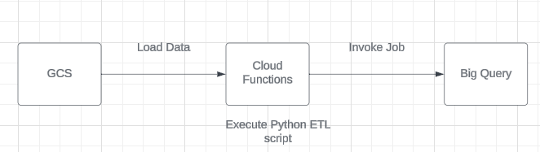

**Step 1:**

* Created a google cloud storage bucket named da-analytics-pipeline3-source.
* Go to Cloud Storage -> click on create a bucket. Provide the details and create a bucket.  
  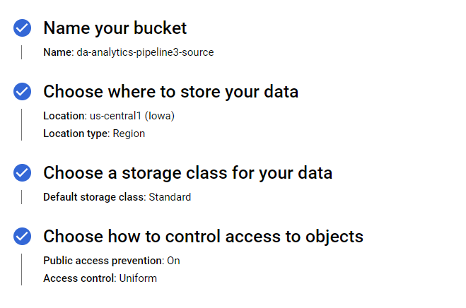

**Step 2:**

* Created a Big query dataset in which we want to dump the data after transformation.
* Go to Big Query-> right click the project and click on dataset.  
  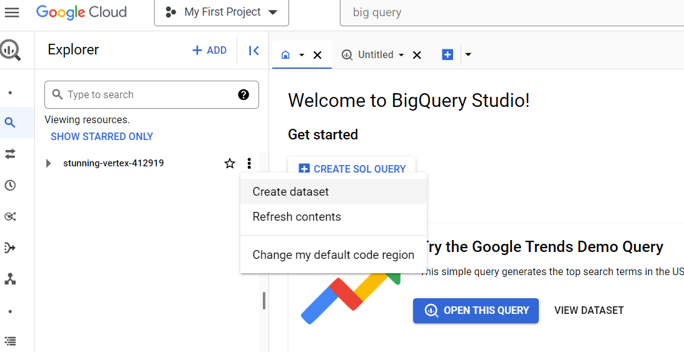
* Provide details like name and region of dataset. And then click on create dataset.  
  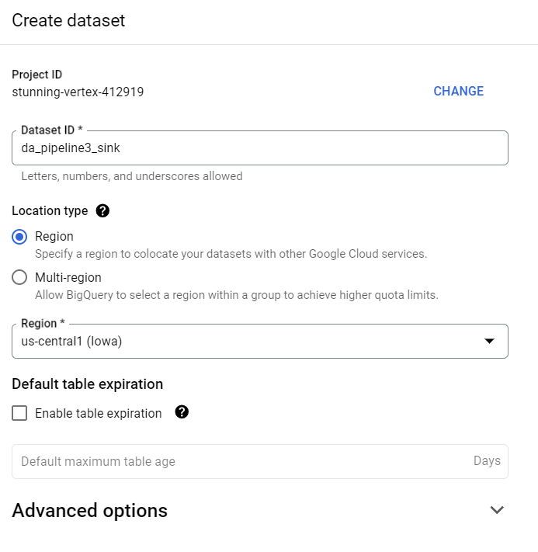
* Created table required where I will dump the data.  
  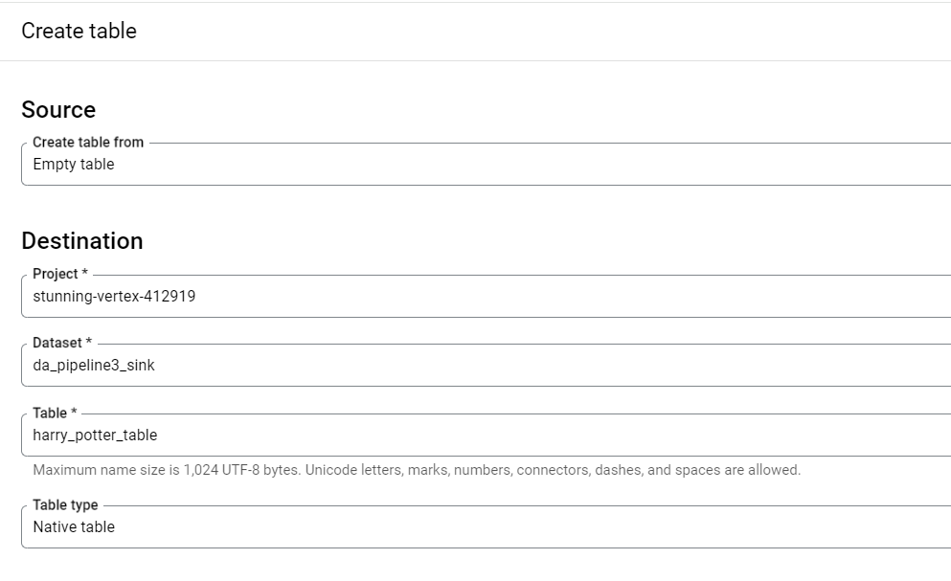  
  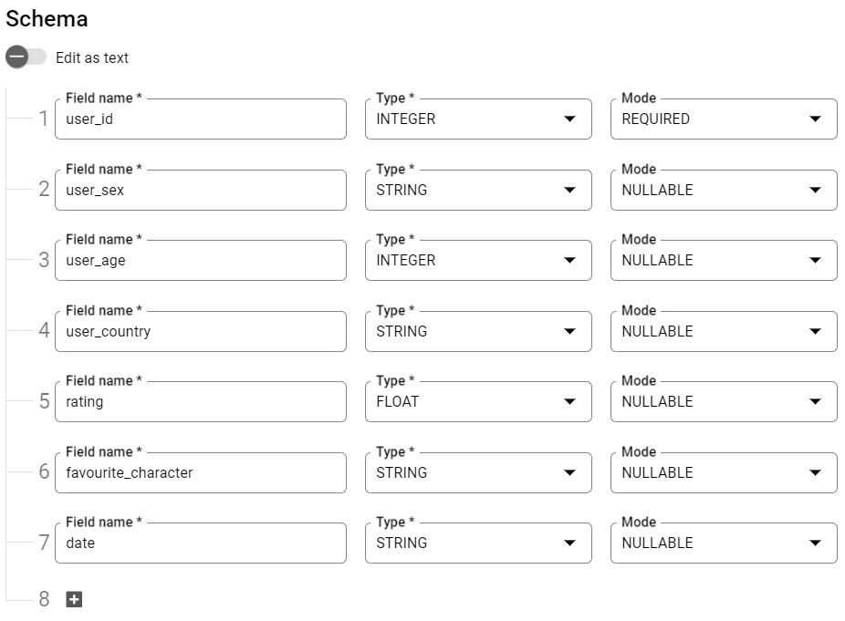

**Step 3:**

* Now we will create a cloud function to read data from GCS, perform transformation using python on that and then put it back into Big Query.
* Create a cloud function and then provide the necessary details.  
  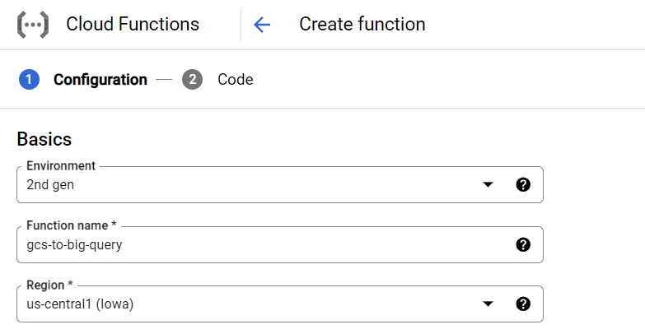
* Now set up a trigger for this cloud function. For now we will use cloud storage event based trigger.  
  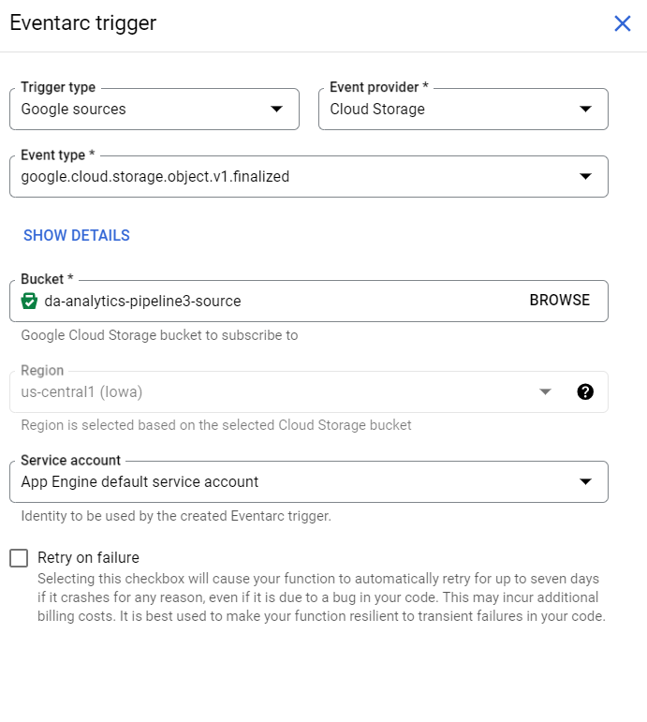
* Specify the other advanced option for runtime.  
  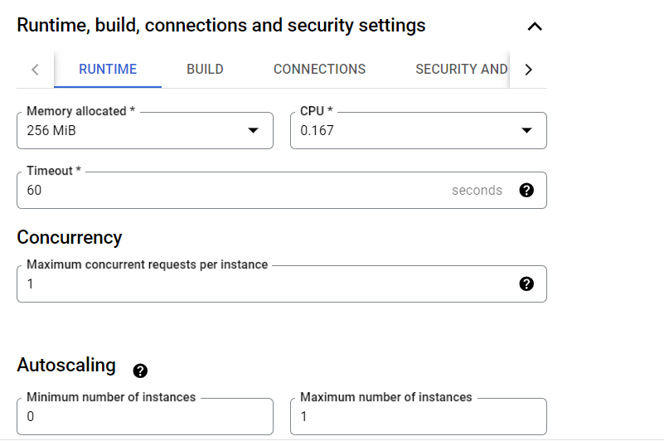
* Write the logic as below:  
  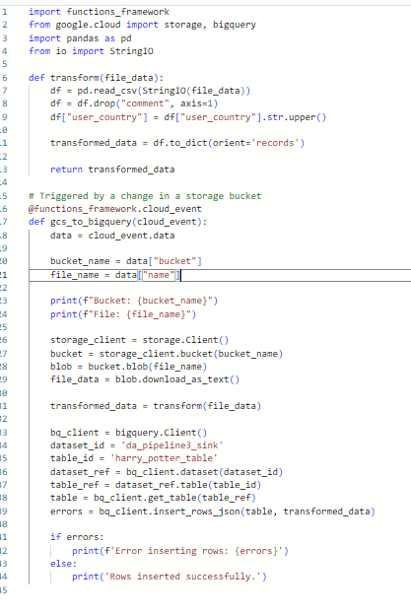

**Step 4:**

* Now upload the file in the bucket, then this Cloud function will get triggered and after success you will receive success message in logs and data get inserted in Big Query table.  
  